Interactive Listening Activities

These activities are offered to help you create simple and accessible ways for people to contribute to the Synod process. You could use them on a Sunday as people gather for Mass, at an event or simply in an area where people ‘pass by’. Most are adaptable in any context where people are gathered and may be able to take a few moments to get involved. The activities overlap in content, so choose the ones which will work best for your setting. You don’t need to try to do them all. (Please follow appropriate Covid-19 regulations.)

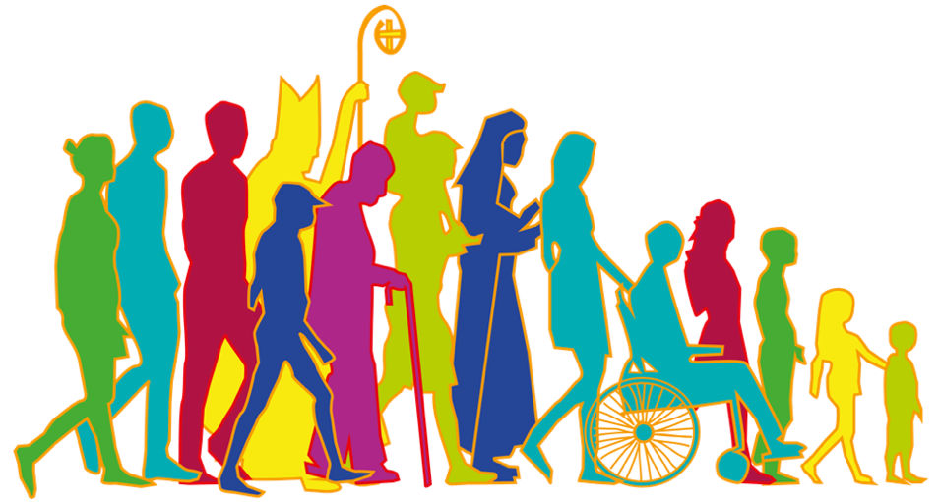

Paired conversations
- Give everyone a blank card and a pen. Invite people to form into pairs, ideally with someone they do not know well, or from a background/situation different to themselves. For example, a young adult could form a pair with an older person.
- One person begins by sharing on the question below for a few minutes. The other person listens deeply, without interruption.

What has been your experience of ‘journeying together’ in your parish/church community? You may want to begin by thinking about the last 18 months. When does this journeying bring joy? When might it bring pain or sadness?

- After a few minutes invite the pairs to switch roles so the other person is sharing/listening.
- When the sharing is complete ask each person to reflect on some of the main things they heard from the other person. Record these on the card. Encourage them to use some of the same words that the person actually spoke. However, it’s not a transcript, just a few key sentences are fine.
- Now exchange cards and allow people to read what the other person heard. On the other side – invite each person to now add any more thoughts of their own.
- If people are happy to, invite them to leave their cards as part of the synodal process.

‘Listening’ Wall
Create four areas in your Church or gathering space for people to add their thoughts about the questions below. You could leave these areas up for a number of weeks, so that people can add at any time, or make it a focussed activity – e.g. after Mass on one of the Sundays in November.

Stick up large flip-chart paper/lining Paper/brown Paper in each of the four spaces. Alternatively, put one long piece of paper along a wall and divide it into four areas. Give each area a large title and write up the corresponding questions.
- Provide people with pens (and, if you wish, sticky notes).
- Invite them to add their reflections, responding to the questions on the wall.
- If people are gathered together to do this, encourage them to read other people’s contributions.
- Invite people to then share with one another a little more about what they wrote. The emphasis is on listening to the experience of others.

Our Experience of COVID-19
- What has been your experience of your Church community ‘journeying together’ these last eighteen months?
- How has your Parish / community ‘journeyed’ with others, outside of the community?

Our Wider Journey
- Recalling your experience of the pandemic, and perhaps thinking more broadly, when does the journeying bring you joy? When might it bring pain or sadness?

Our Church Community
- When we say ‘our Church’, who is part of it?
- Who is missing on this journey? Whom do we need to listen to?

Our Mission
- What would you wish to celebrate about how your parish/community lives its mission?
- What areas of mission are we neglecting?

Table Top Map
Print out a very large map of the parish/local community. You can print this out in sections and stick it together. Alternatively purchase a large scale AtoZ of your area and tape the pages together. Place the map on several large tables pushed together, with room to walk around.

- Provide paper flags (on cocktail sticks with plasticine bases) or sticky notes. Invite people to write on the flags/notes and then add them to the map. If you wish, you can use two different coloured flags/sticky notes to indicate different categories of responses. E.g.
- Colour one: Where are members of our community engaged in living out the Church’s mission?
- Colour two: Where do you see opportunities for the Church’s mission to grow?
- Colour three: Where so we see opportunities to build relationships and journey with others?

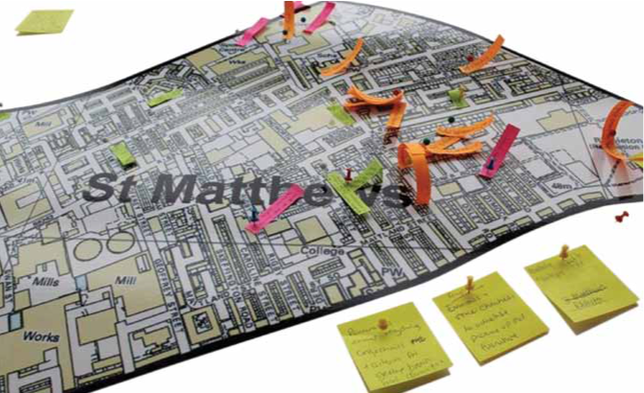

Multi Voting
Work in a small group to choose areas of mission which your Church community could develop further e.g:
- Responding to food-poverty
- Supporting the lonely
- Accompanying migrants/refugees
- Accompanying people in financial hardship
- Outreach to young people ‘on the margins’
- Homelessness
- Caring for creation in our local community
- Journeying with those who are unemployed

On different sheets of A4/A3 paper print out these titles of ‘areas of mission’. Or get creative and write them on circles of coloured card.
- Give people three sticky dots.
- Invite each person to use their dots to ‘vote’ for the areas of mission which the parish/community might prioritise.
- People can distribute their votes how they like – even placing all three dots in one area.

Spectrum of experience

- On the wall, or display boards, place three large sheets of paper, landscape orientation, spaced apart (e.g use flip chart or lining paper/brown paper). Entitle each one ‘Our Church Community’
- Draw large double-ended arrows on each piece of paper and label them to create ‘spectrums’ of experience. Label the spectrums as below. Include a midpoint by adding a centre mark (See photo)

I don’t feel included <-----------Somewhere in between------------> I feel included
We are inward-looking <------------------I don’t know ----------------> We are mission-focussed
I don’t feel joyful < --------------------- sometimes -------------------- > I mostly feel joyful

- Invite people to place a dot anywhere on each of the scale.

- Once everyone has added their dot you may want to gather in a group to consider the scales. Or you can reflect at a later date as part of preparing your summary feedback report. Ask:
- What might this say about the experience of people in our Church community?
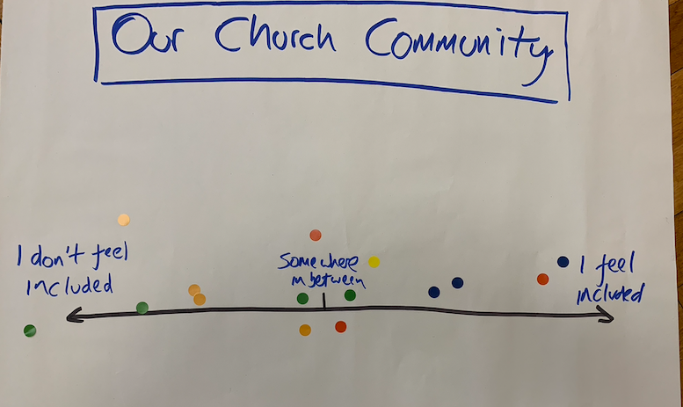

Visual Mind Mapping
Place one of the following questions/statements in the middle of a very large sheet of paper (e.g. a large sheet of brown paper). The paper should be big enough for all the small group to access at once. You can tape the paper on the wall, or place it on a large table.

“Our Journeying together as Church during COVID-19”

“How does our journeying together bring joy … how might it bring pain or sadness?”

“When we say ‘our Church’, who is part of it? Who is missing on this journey?”

- If possible, invite people to add to the visual mind map over several weeks.
- Provide markers of bold colours or thick tipped felt pens.
- Invite people to write (or draw) anywhere on the paper, as they reflect on the question/statement. Explain that they can use lines, arrows, colours to connect ideas. Underline keywords or circle them in a colour. (Add a few examples yourself to get it started)
There is no ‘one right way’ to do this. Each mind map will be different. It will simply be a visual representation of your community’s reflections.
- You may want to gather with a group at a later date as part of preparing your summary feedback report. Ask:
What might this say about the experience of people in our Church community?

